TFT Model Progress Report

Iteration 1 – Predicting for 3 months.
Iteration Kind | MONTH | PREDICTED_SALES
No feature engineering. Original Covariates | Jun-26 | 2,79,581
 | Jul-26 | 55,206
 | Aug-26 | 53,696
No feature engineering. Swapped Covariates with previous year i.e., 2025 covariates | Jun-26 | 3,93,843
 | Jul-26 | 3,43,243
 | Aug-26 | 3,49,957
Feature engineering done. Details of feature engineering done is captured in the .txt file. | Jun-26 | 2,97,713
 | Jul-26 | 2,69,899
 | Aug-26 | 2,76,194

Feature engineering strategy:
- Since PITRU_PAKSH and PITRAPAKSHA_DAYS both are same, Will drop PITRAPAKSHA_DAYS column

- Removed following columns:
- 'TOTAL_DAYS_FESTIVE_PHASE_I'
- 'TOTAL_DAYS_FESTIVE_PHASE_II'
- 'TOTAL_DAYS_FESTIVE_PHASE_III'
- 'TOTAL_DAYS_PITRU_PAKSH'
Why? : Because these columns are either 0 or same for all the months
- Removed following columns:
- PROP_EVENT_PITRU_PAKSH
- PROP_EVENT_FESTIVE_PHASE_I
- PROP_EVENT_FESTIVE_PHASE_II
- PROP_EVENT_FESTIVE_PHASE_III
- NUM_FESTIVE_DAYS_MONTH

- Collapsed the following festival columns to TOTAL_FESTIVAL_DAYS

['DUSSEHRA_(VIJAYADASHAMI)_DAYS',
'AKSHAYA_TRITIYA_DAYS',
'BHAI_DOOJ_DAYS',
'BUDDHA_PURNIMA_DAYS',
'CHHATH_PUJA_DAYS',
'DHANTERAS_DAYS',
'DIWALI_DAYS',
'EID_UL_FITR_DAYS',
'GANESH_CHATURTHI_DAYS',
'GANGA_DUSSEHRA_DAYS',
'GOVARDHAN_POOJA_DAYS',
'GURU_PURNIMA_DAYS',
'HANUMAN_JAYANTI_DAYS',
'HARTALIK_TEEJ_DAYS',
'HOLI_DAYS',
'HOLIKA_DAHAN_DAYS',
'JAGANNATH_RATHYATRA_DAYS',
'JANMASHTAMI_DAYS',
'KARWA_CHAUTH_DAYS',
'LOHRI_DAYS',
'MAHA_SHIVARATRI_DAYS',
'MAKAR_SANKRANTI_PONGAL_DAYS',
'NAG_PANCHAMI_DAYS',
'NAVRATRI_DAYS',
'NEW_YEAR_DAYS',
'ONAM_DAYS',
'RAKSHA_BANDHAN_DAYS',
'REPUBLIC_DAY_DAYS',
'VASANT_PANCHAMI_DAYS',
'VISHWAKARMA_PUJA_DAYS']

Created a column called as LAST_YEAR_CONTRIBUTION of a specific month.

LAST_YEAR_CONTRIBUTION - For April 2023 it will be - Contribution of each month - (April 2022 sales/FY'23 total sales)

Iteration 2 – Predicting for 6 month horizon with engineered features
loss_logger = LossLogger()

model = TFTModel(
input_chunk_length=12,
output_chunk_length=6,
batch_size=512,
dropout=0.1,
likelihood=None,
loss_fn=torch.nn.MSELoss(),
n_epochs=100,
random_state=42,
add_encoders=add_encoders,
model_name=MODEL_NAME,
work_dir=WORK_DIR,

# CRITICAL CHANGE: Tell Darts to handle its native model manifest building
save_checkpoints=True,
force_reset=True,

pl_trainer_kwargs={
"callbacks": [
loss_logger,
early_stop_callback
],
"enable_checkpointing": True,
"gradient_clip_val": 0.1
}
)

print("\nRunning LR Finder...")
lr_finder = model.lr_find(
series=scaled_target_series_with_static_covariates_training,
future_covariates=scaled_future_covariates_training,
)

suggested_lr = lr_finder.suggestion()
print("Suggested Learning Rate:", suggested_lr)
model.lr = suggested_lr

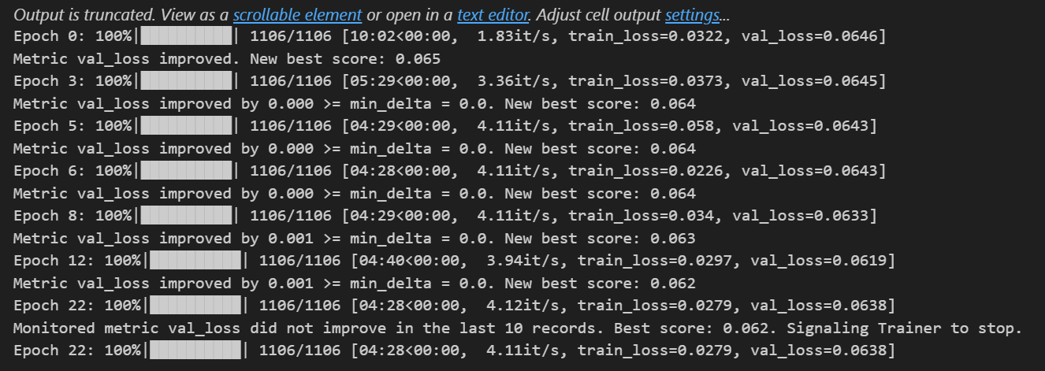
Output came out as
MONTH_NAME | PREDICTED_SALES
June | 386790
July | 350689
August | 335238
September | 316078
October | 635328
November | 596278

Iteration 3 – Prediction for 6 month horizon with modified configuration
1. Train set : Apr'23 to May'25
2. Val set : June'24 to May'26
3. Lookback data : Feb'25 to May'26
4. Lookahead data : June'26 to Nov'26
5. Epochs increased from 100 to 200
6. Patience increased from 10 to 25
7. input_chunk_length increased from 12 to 16
8. Loss changed to Quantile loss
9. Output using the mean prediction from Quantile loss
MONTH_NAME | TFT_PREDICTED_MONTHLY_SALES
June | 4,16,260
July | 3,35,549
August | 2,94,278
September | 2,64,782
October | 12,34,499
November | 8,52,511

Deviation from the last 4 year average sales and the last year sales using mean prediction from quantile loss is as given below.
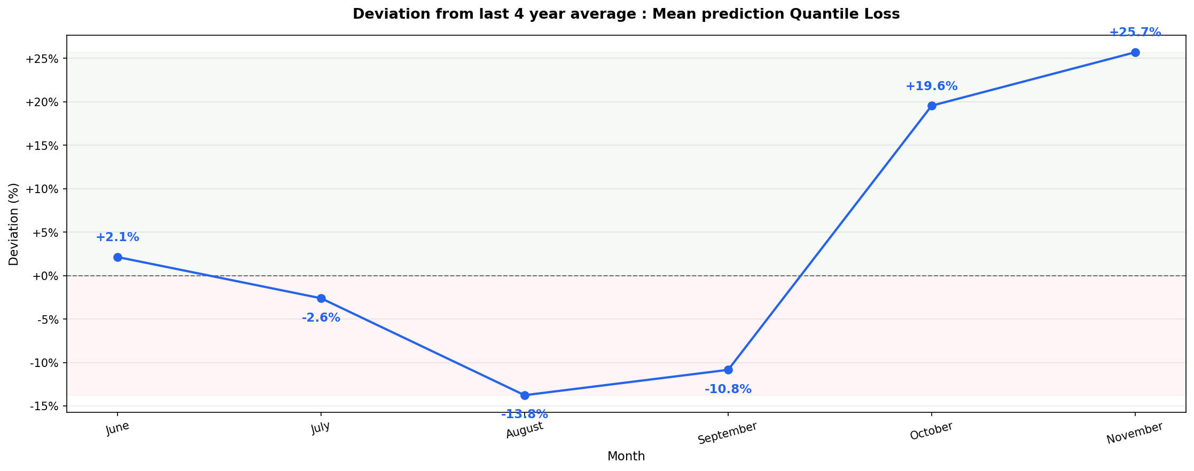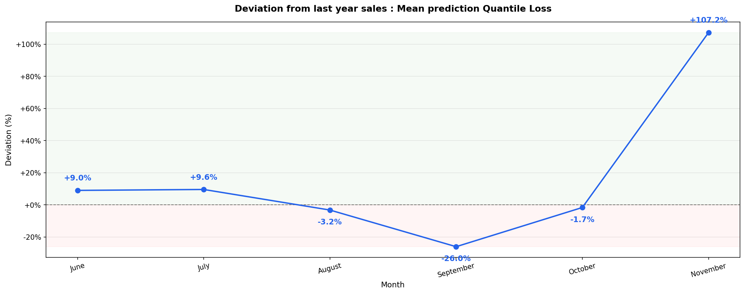

Iteration 4 – Prediction for 6 month horizon with modified configuration
1. Train set : Apr'23 to May'25
2. Val set : June'24 to May'26
3. Lookback data : Feb'25 to May'26
4. Lookahead data : June'26 to Nov'26
5. Epochs increased from 100 to 200
6. Patience increased from 10 to 25
7. input_chunk_length increased from 12 to 16
8. Loss changed to Quantile loss
9. Output using the percentiles from Quantile loss
MONTH_NAME | TOTAL_MONTHLY_SALES_P10 | TOTAL_MONTHLY_SALES_P50 | TOTAL_MONTHLY_SALES_P90
June | 1,31,205 | 3,50,816 | 7,87,673
July | 1,02,561 | 2,87,514 | 6,36,908
August | 82,101 | 2,47,342 | 5,71,676
September | 79,907 | 2,15,034 | 5,15,230
October | 5,38,560 | 13,03,353 | 18,32,654
November | 2,09,857 | 7,24,979 | 16,46,160

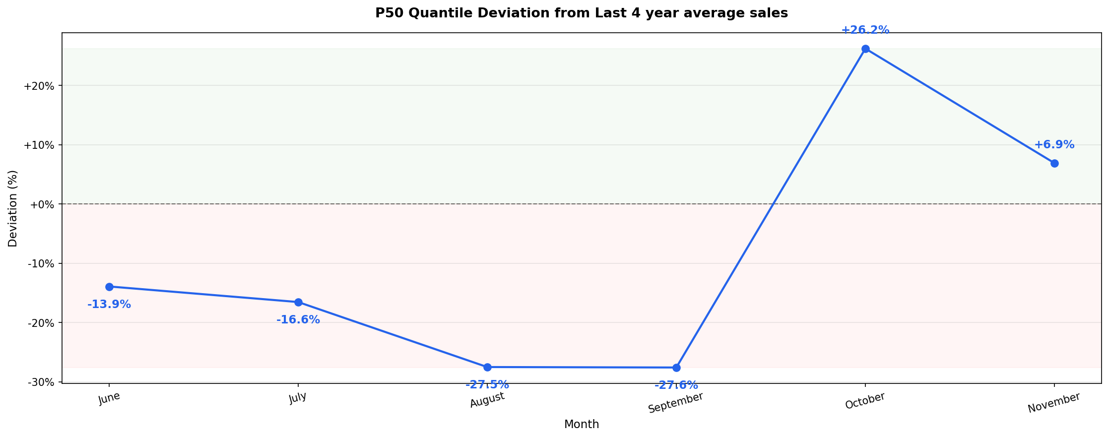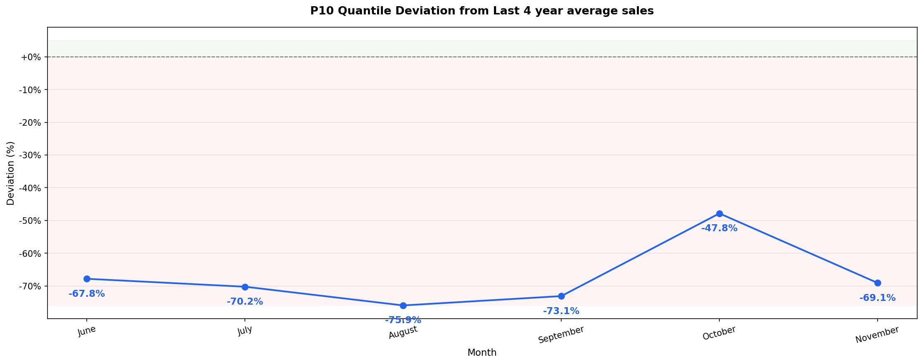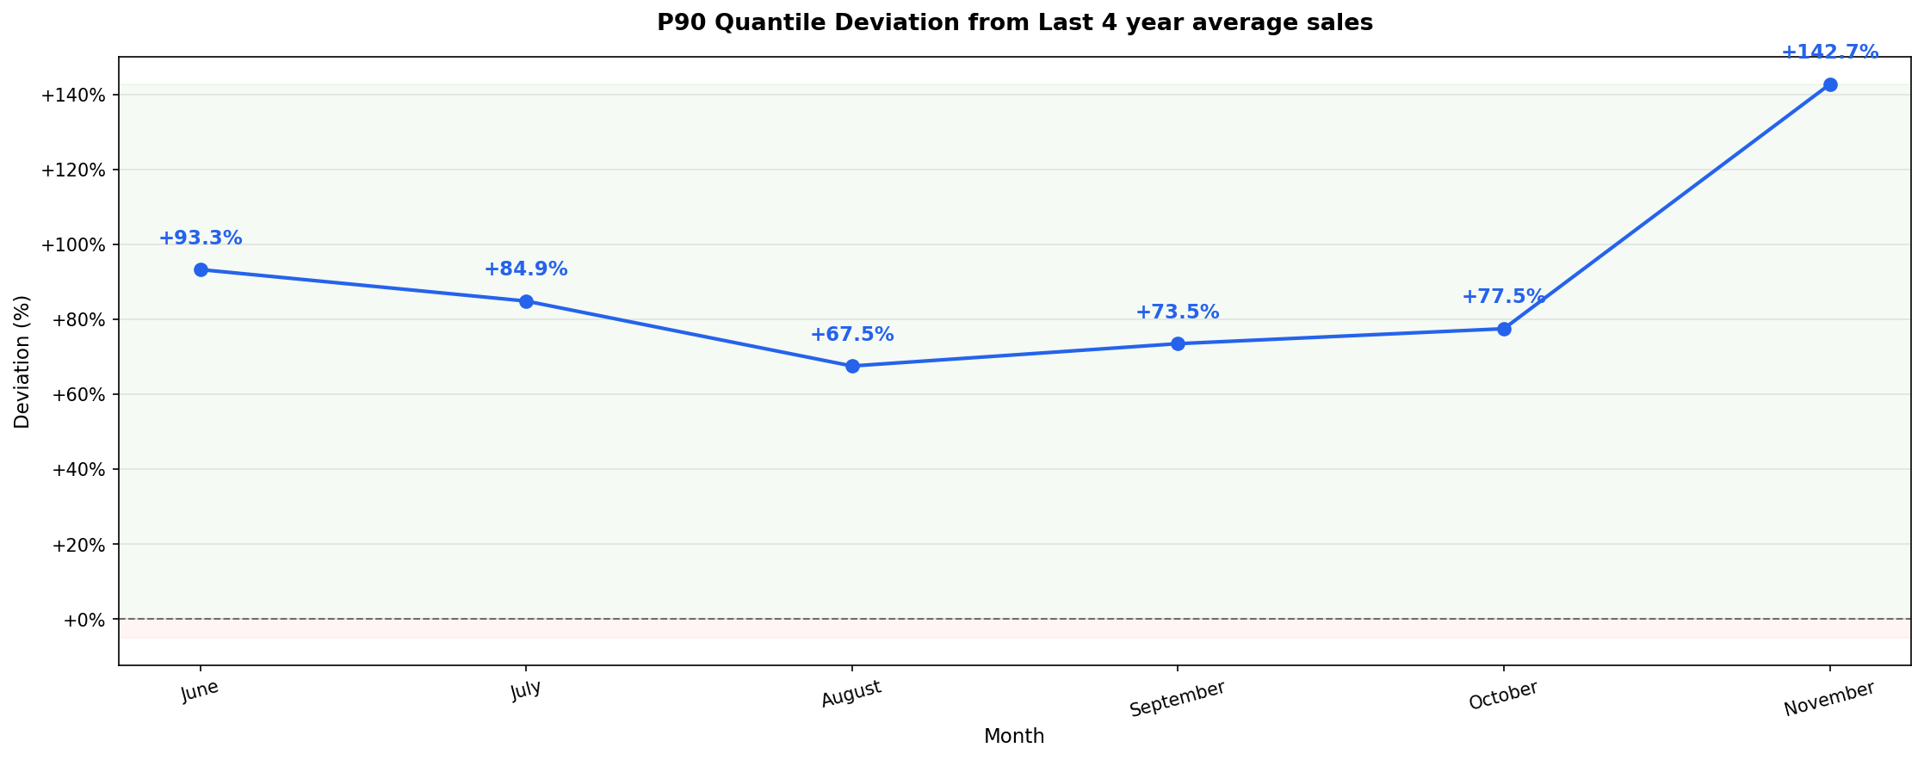

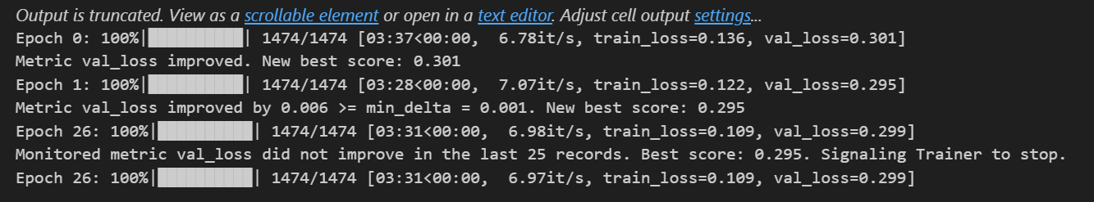
Train and val loss using quantile loss

loss_logger = LossLogger()

model = TFTModel(
input_chunk_length=16,
output_chunk_length=6,
batch_size=128,
dropout=0.1,
likelihood=QuantileRegression(quantiles=[0.1,0.5,0.9]),
loss_fn=None,
n_epochs=100,
random_state=42,
add_encoders=add_encoders,
model_name=MODEL_NAME,
work_dir=WORK_DIR,

# CRITICAL CHANGE: Tell Darts to handle its native model manifest building
save_checkpoints=True,
force_reset=True,

pl_trainer_kwargs={
"callbacks": [
loss_logger,
early_stop_callback
],
"enable_checkpointing": True,
"gradient_clip_val": 0.1
}
)

print("\nRunning LR Finder...")
lr_finder = model.lr_find(
series=scaled_target_series_with_static_covariates_training,
future_covariates=scaled_future_covariates_training,
)

suggested_lr = lr_finder.suggestion()
print("Suggested Learning Rate:", suggested_lr)
model.lr = suggested_lr
model architecture using quantile loss
Iteration 5 – Prediction for 6 month horizon with modified configuration
1. Train set : Apr'23 to May'25
2. Val set : June'24 to May'26
3. Lookback data : Feb'25 to May'26
4. Lookahead data : June'26 to Nov'26
5. Epochs increased from 100 to 200
6. Patience increased from 10 to 25
7. input_chunk_length increased from 12 to 16
8. Loss changed to Quantile loss
9. Output using the percentiles from Quantile loss
MONTH_NAME | TOTAL_MONTHLY_SALES_P10 | TOTAL_MONTHLY_SALES_P50 | TOTAL_MONTHLY_SALES_P90
June | 1,31,205 | 3,50,816 | 7,87,673
July | 1,02,561 | 2,87,514 | 6,36,908
August | 82,101 | 2,47,342 | 5,71,676
September | 79,907 | 2,15,034 | 5,15,230
October | 5,38,560 | 13,03,353 | 18,32,654
November | 2,09,857 | 7,24,979 | 16,46,160





Iteration 6 – Prediction for 6 month horizon with modified configuration
1. Train set : Apr'23 to May'25
2. Val set : June'24 to May'26
3. Lookback data : Feb'25 to May'26
4. Lookahead data : June'26 to Nov'26
5. Epochs increased from 100 to 200
6. Patience increased from 10 to 25
7. input_chunk_length increased from 12 to 16
8. Loss changed to Huber loss
MONTH_NAME | TOTAL_PREDICTED_SALES
June | 5,07,213
July | 4,04,020
August | 3,68,492
September | 3,38,404
October | 12,83,292
November | 6,71,600

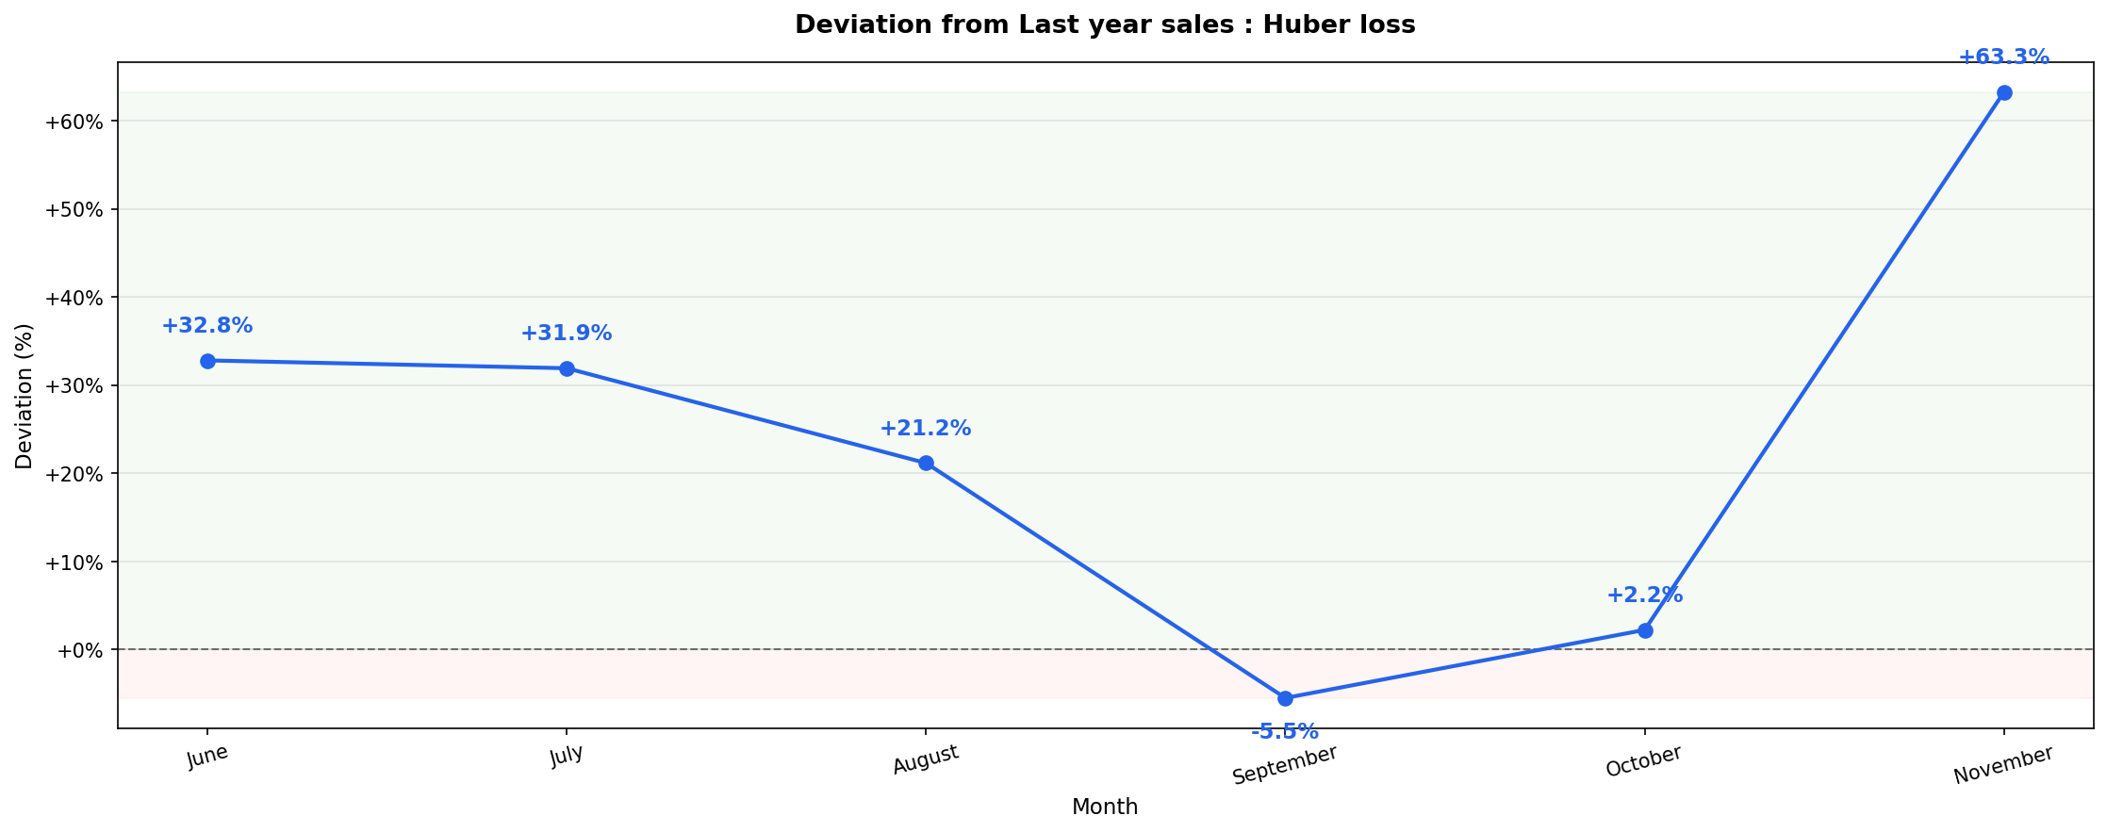

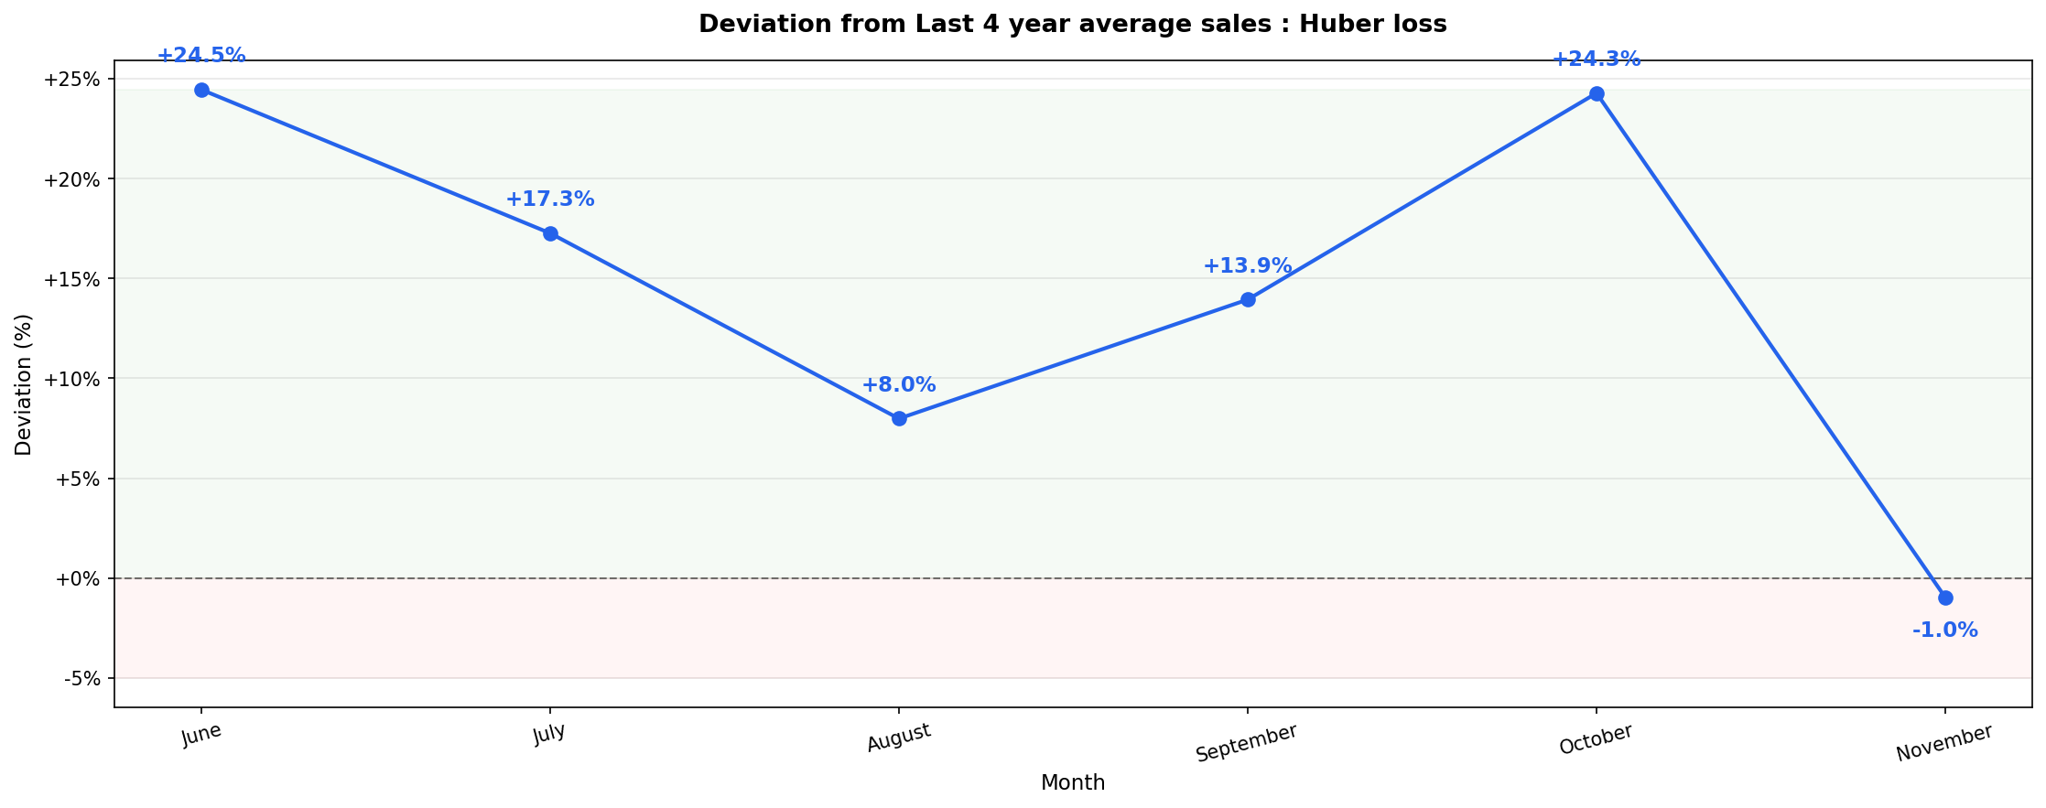

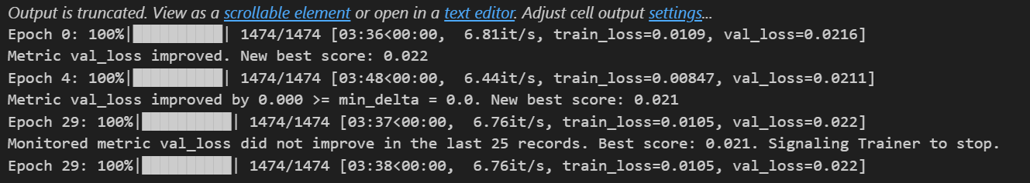
Output of train loss and val loss for Huber loss

loss_logger = LossLogger()

model = TFTModel(
input_chunk_length=16,
output_chunk_length=6,
batch_size=128,
dropout=0.1,
likelihood=None,
loss_fn=torch.nn.HuberLoss(delta=0.1),
n_epochs=200,
random_state=42,
add_encoders=add_encoders,
model_name=MODEL_NAME,
work_dir=WORK_DIR,

# CRITICAL CHANGE: Tell Darts to handle its native model manifest building
save_checkpoints=True,
force_reset=True,

pl_trainer_kwargs={
"callbacks": [
loss_logger,
early_stop_callback
],
"enable_checkpointing": True,
"gradient_clip_val": 0.1
}
)

print("\nRunning LR Finder...")
lr_finder = model.lr_find(
series=scaled_target_series_with_static_covariates_training,
future_covariates=scaled_future_covariates_training,
)

suggested_lr = lr_finder.suggestion()
print("Suggested Learning Rate:", suggested_lr)
model.lr = suggested_lr

model architecture of Huber loss

Details as requested by Soumakshya
- Backtested both the models i.e., Quantile loss trained model and Huber loss model on June 2025 to November 2025.
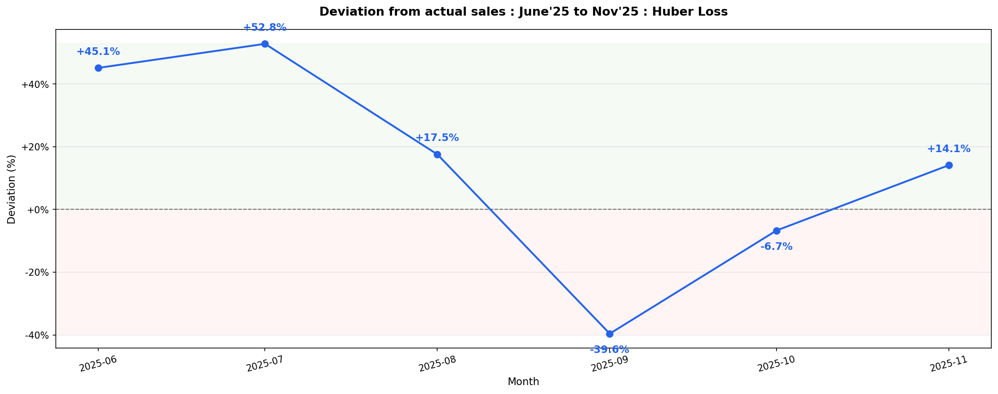

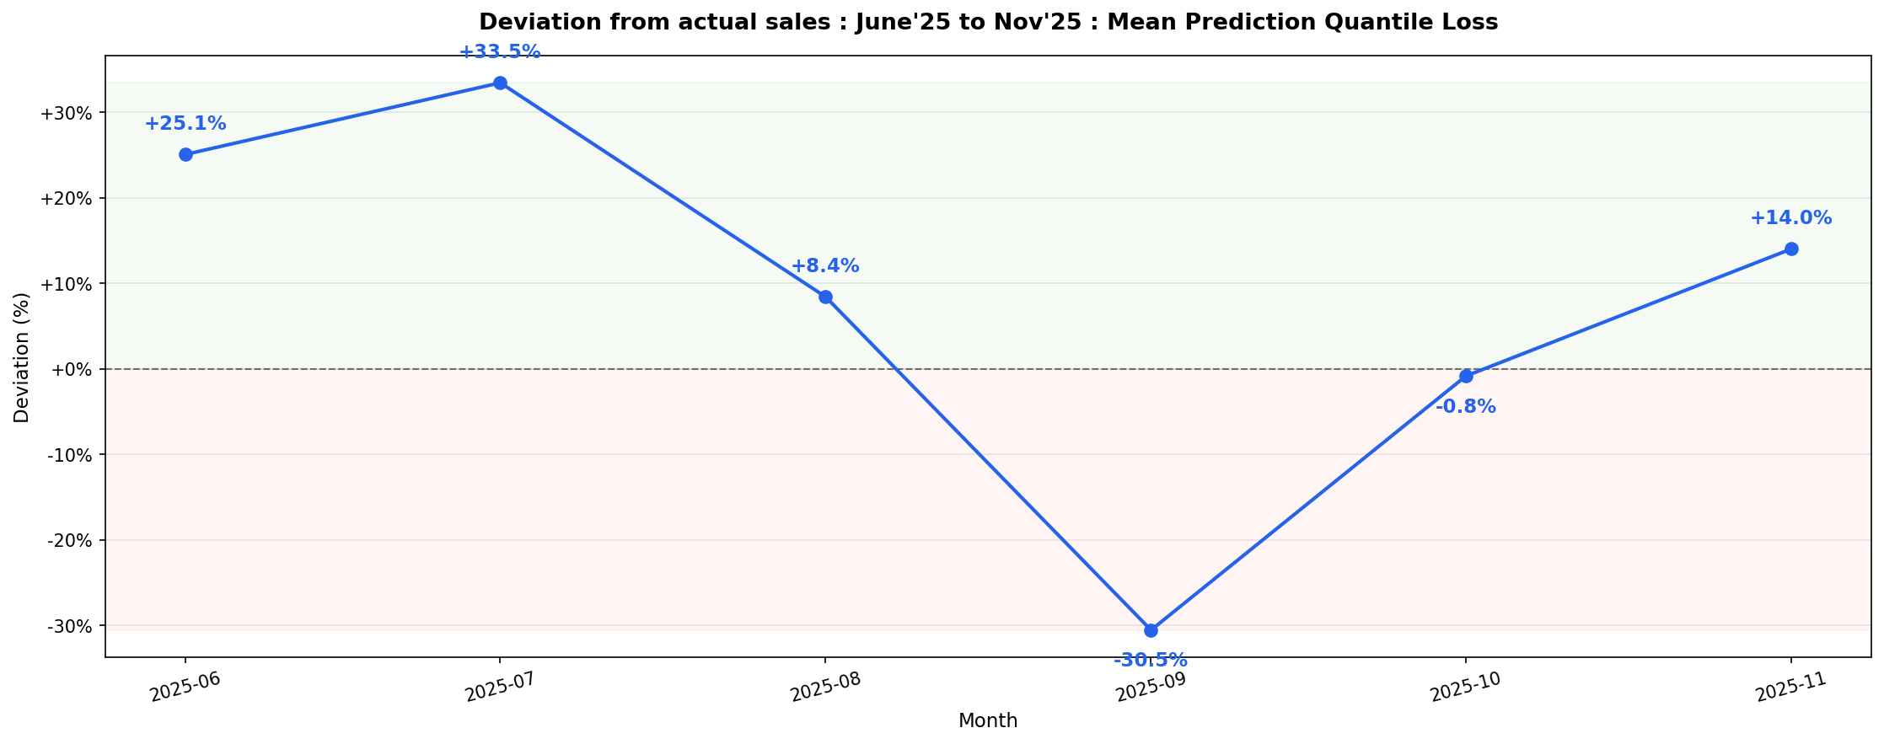

- Encoder and decoder importance

An additional smoking gun that I found – When training the model with input_chunk_length as 16, the model’s training was ending on May’25 so model was not able to see the entire FY’26 which had a decline. I believe this could be the cause of the overprediction by the model.
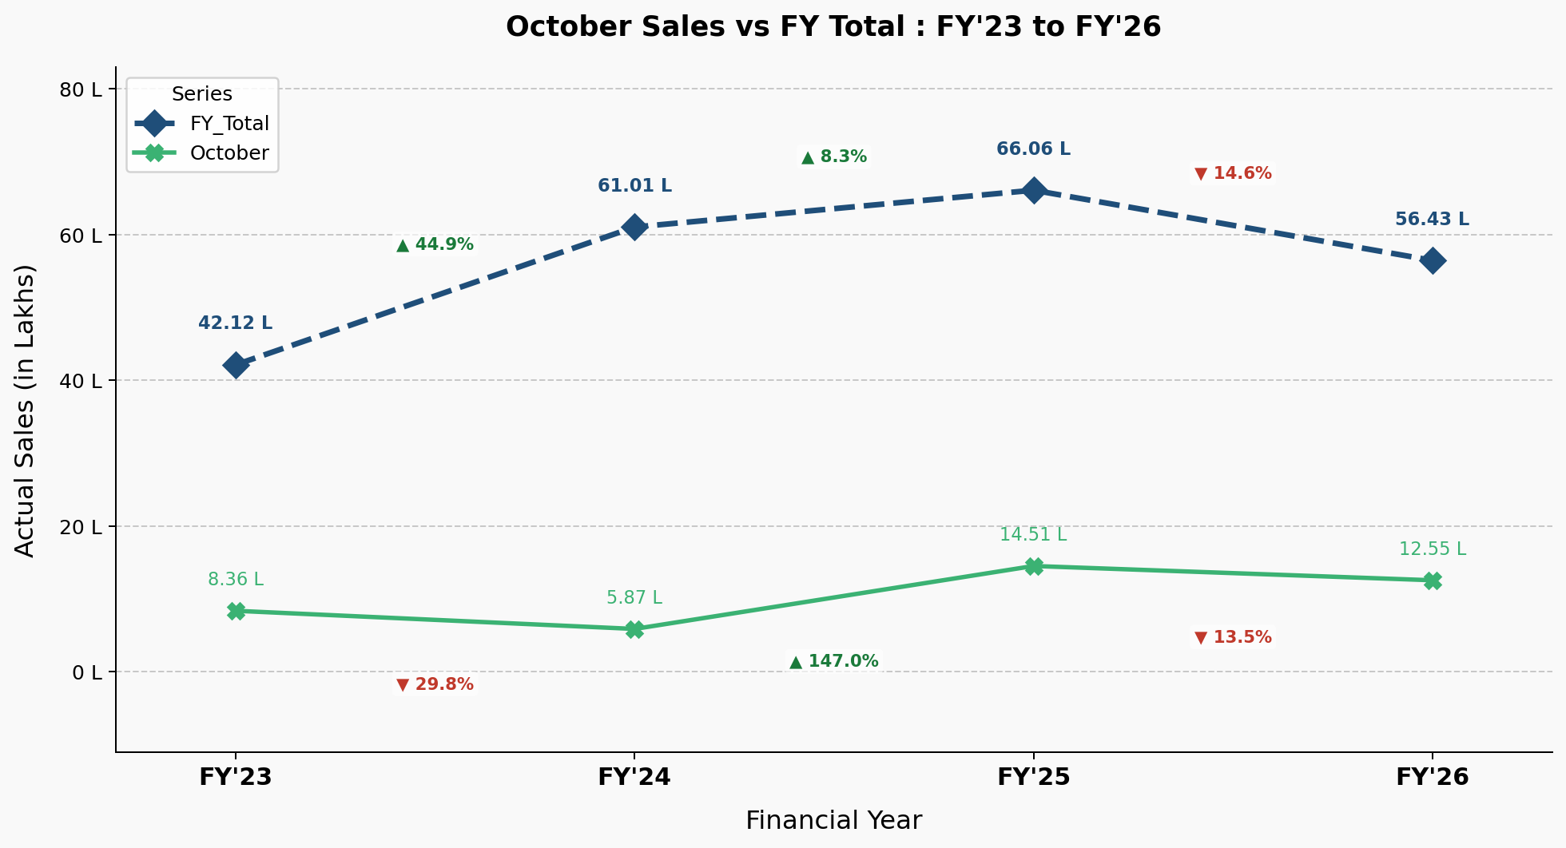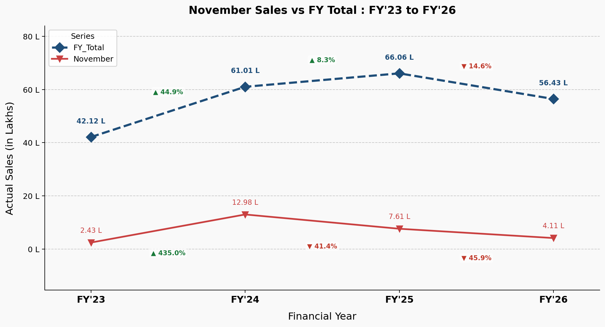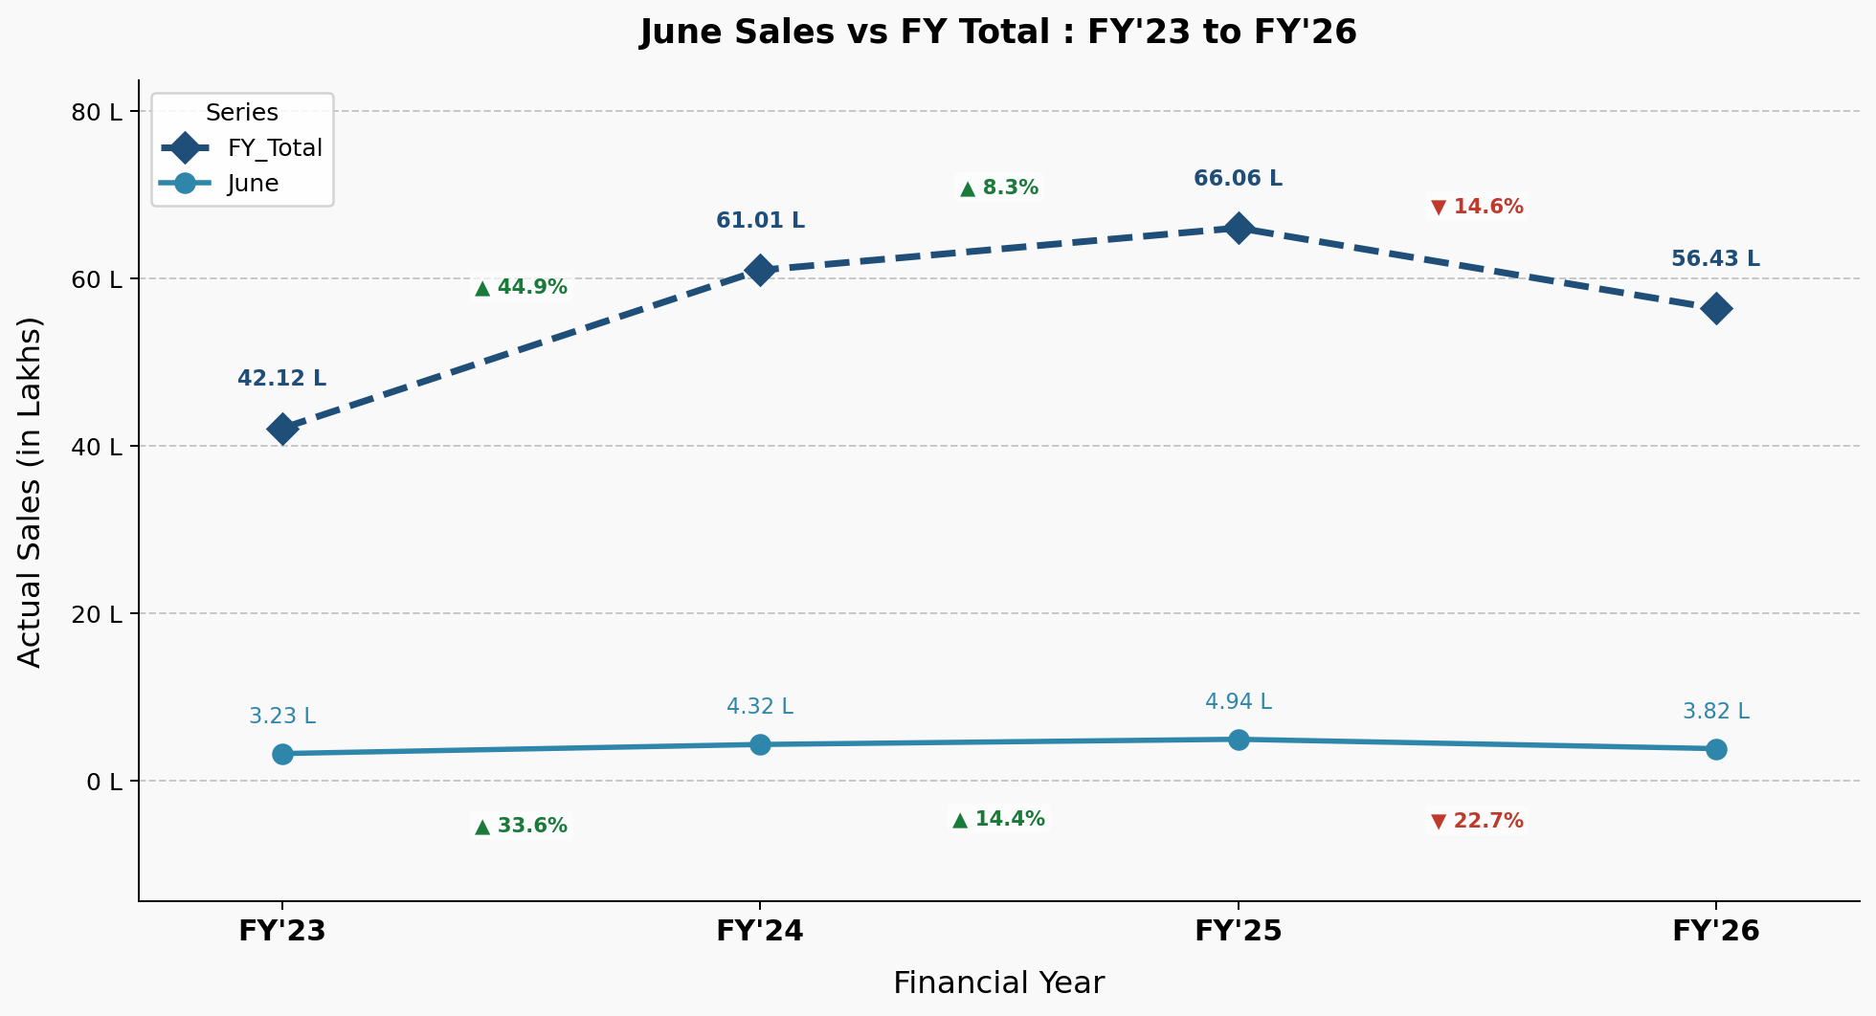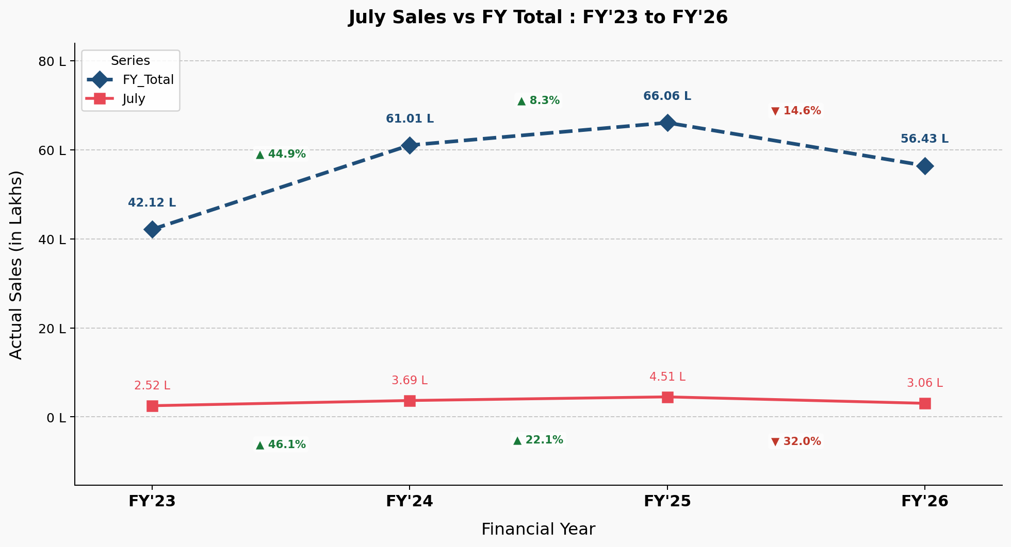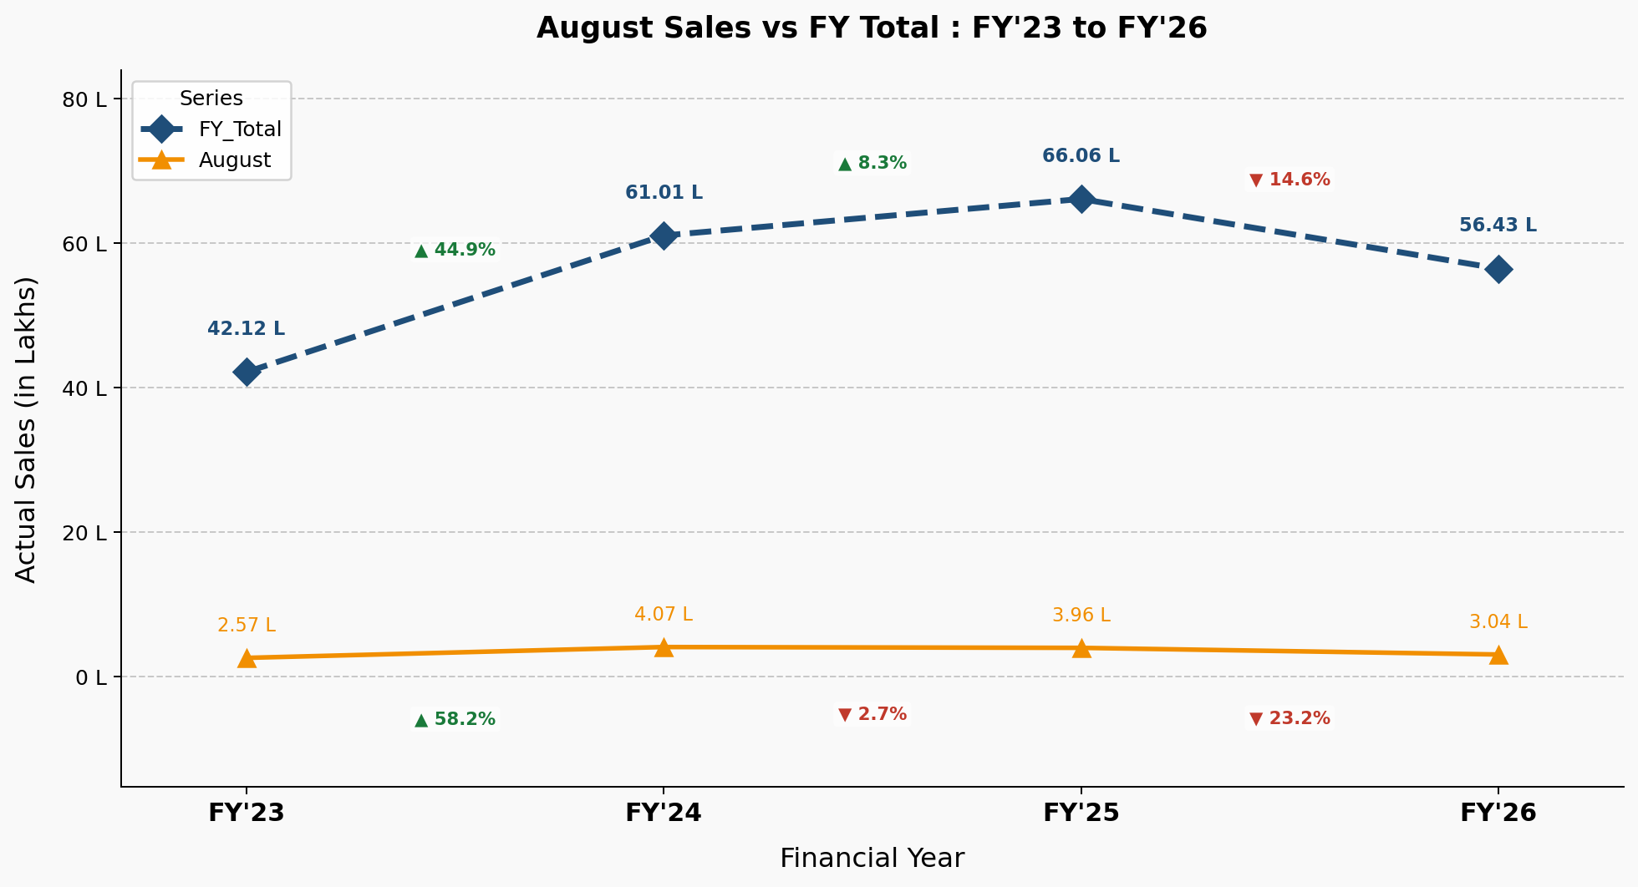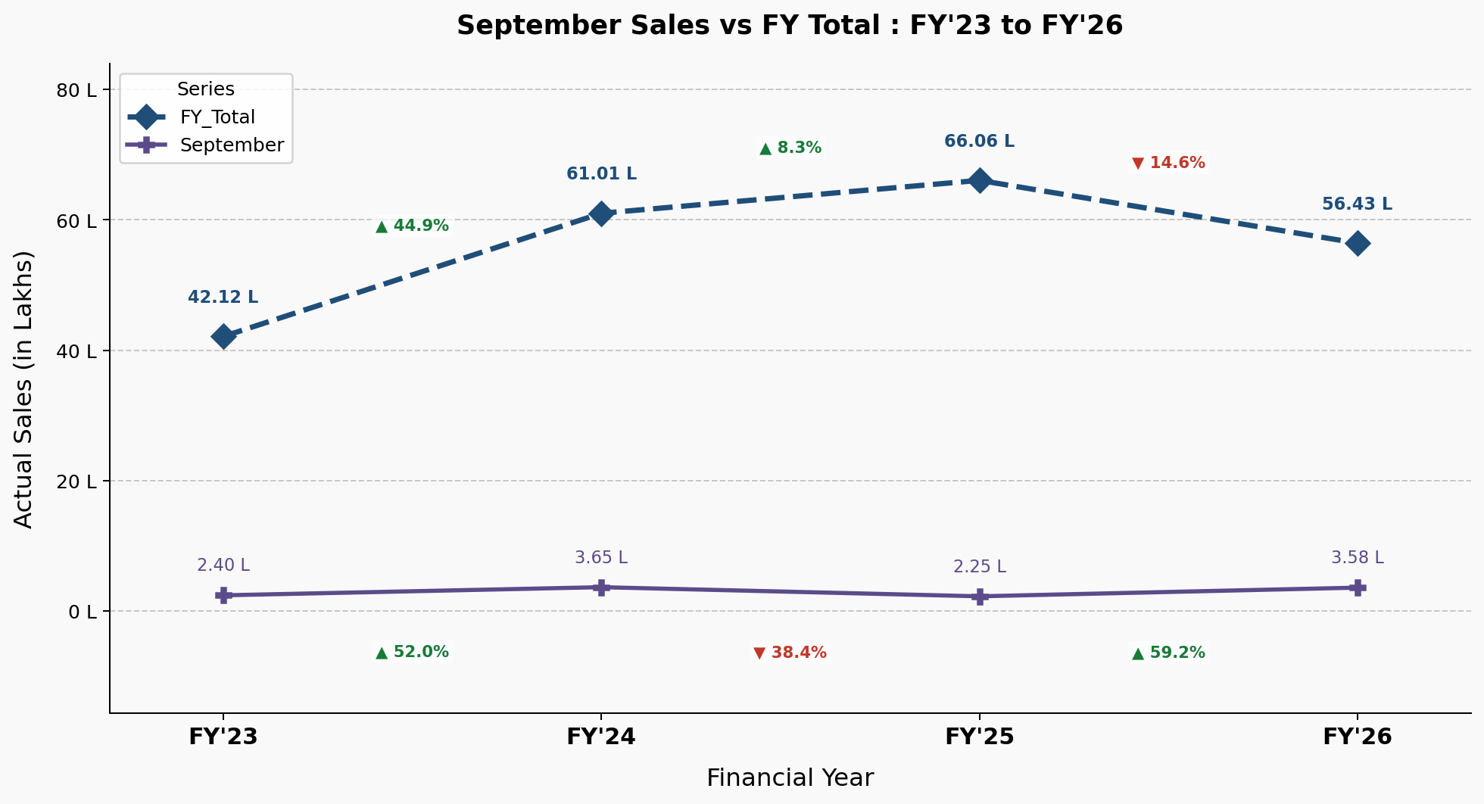

Recommendation – To handle the momentum issue, I am currently trying this –

---Configuration to handle the momentum issue---
input_chunk_length = 12
output_chunk_length = 6
Training data - Apr'23 to Sep'25
Val data - Oct'24 to May'26
Lookback data - Jun'25 to May'26
Lookahead data - June'26 to Nov'26
Loss - QuantileLoss
Epochs - 200
Patience - 25
Batch_size - 128

